It’s Personalised, It’s Customised, It Sticks, It Works 01

it’s personalised
it’s customised
it sticks it works

The idea of Lumina Learning was formed after many discussions with academics and business leaders. Our main objective is to move from old, transactional approaches to newer, creative ones in order to help organisations see people, their most valuable resource, not as human doings, but as human beings.

the big idea
One of the unique aspects of Lumina Learning’s approach is the humanistic idea of embracing paradox. For example, in any team there can be team members who seem to have diametrically opposed personality traits. When these team members are able to value each other’s differences, teamwork can flourish, rather than clash. Therefore, Lumina’s tools can help solve issues that the organisation may be facing by resolving conflicts and by helping teams to work together harmoniously, leading to increased productivity.

We’ve found that every individual possesses opposing personality traits. Our tools aid personal development by assisting others in embracing all their personality traits and working to build on their strengths and examine their weaknesses. Our work clearly indicates that individuals who are willing to look inside and embrace their own diametrically opposed personality traits can significantly improve their personal effectiveness and enhance performance.

He who knows others is wise.
“
He who knows himself is enlightened
- Lao Tzu

introducing
lumina spark
Lumina Spark is the latest innovation in professional development and assessment tools as it breaks free from the world of dry, out-of-date psychometrics and stereotyping personality tests. Every other type of technology has advanced at a blinding rate, so we thought it was time to give what we like to call ‘people technologies’ a 21st-century upgrade too. This is even more necessary given that as businesses today are so diverse and dynamic, any solutions must be equally complex and robust.

The Lumina Spark model is the result of years of research combining expert knowledge with human integrity, building on precisely what works n psychometric assessment for businesses and eliminating what doesn’t. Our framework aids self-understanding and rapport-building in a way that is authentic and practical yet easily customisable to suit your needs and values.

If you are...

... looking for new and exciting ways to enhance the working relationships within your organisation,

… but sceptical of the benefits and ethics behind today’s assessment tools,

Lumina Spark will give you, your business and your people the solutions you are looking for.

©2013 Lumina Learning It’s Personalised, It’s Customised, It Sticks, It Works 03

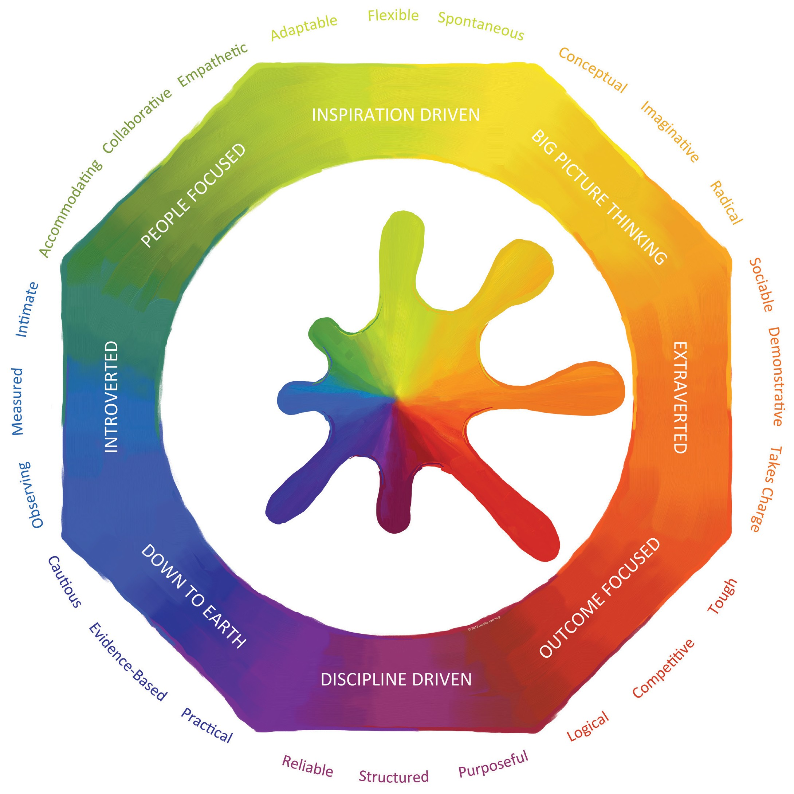

We invite you and your team to take an online 144- item questionnaire.

how does
lumina spark
work?
Based on how you answered the questionnaire, we paint a ‘Portrait’ for you - a personalised document that is full of insightful information on yourself and your relationship with others.

Using your Portrait as core material alongside workbooks, mats and cards, our highly trained professional facilitators will work with you and your team on a specialised programme that will be designed in collaboration with you to bring you the desired results.

04 It’s Personalised, It’s Customised, It Sticks, It Works ©2013 Lumina Learning

no stereotypes
no labels
no boxes
no cells

It’s Personalised
We measure 24 Qualities on a continuum - we call
these ‘traits’ not ‘types’. We want all our products and
services to value you as an individual so that working
with us offers a genuine, personal experience.

It’s Customised
Our validated psychometrics, systems and resources
are completely customisable. With each customer we
are determined to tailor our services to provide you
and your business with the solutions and focus you are
looking for.

It Sticks
We use memorable colours and jargon-free, practical
language that allow people to quickly grasp and
internalise our model. Despite Lumina Spark’s
sophistication, it is elegantly constructed into three
levels: Four Colours, Eight Aspects and 24 Qualities.
No other model offers the same level of depth and
accessibility.

It Works
We take pride in the scientific rigour behind our
model. Based on the latest in Big5 research and certain
elements of the Jungian lens, we are able to measure
what we call your ‘Three Personas’ - the underlying
you, the everyday you and the overextended you.
Another distinct feature of the Lumina Spark model is
what we call ‘Embracing Paradox’, which recognises
the complex contradictions that make each one
of us unique. We use ‘both/and’ thinking and do
not pigeonhole people with the dated ‘either/or’
approach.

©2013 Lumina Learning It’s Personalised, It’s Customised, It Sticks, It Works 05

“Having experienced a Lumina Spark workshop I have become more and more effective in my ability to run projects and handle the people side of things. My teams are experiencing less conflict and I feel great gratitude to the facilitators that helped me learn and grow in such a powerful way.”

some kind words
from our customers
“I was a big-time sceptic but after my experience of working with Lumina Learning I have a renewed faith in psychometric assessment. Lumina Spark is a fun and a fantastic way to learn about yourself and those around you.”

“This is the most practical and inspirational method for raising our staff’s self-awareness and improving communication that I have ever experienced.”

“The team are friendly, and brilliant. Their services live up to the values they promise on their homepage and that for me was very, very important.”

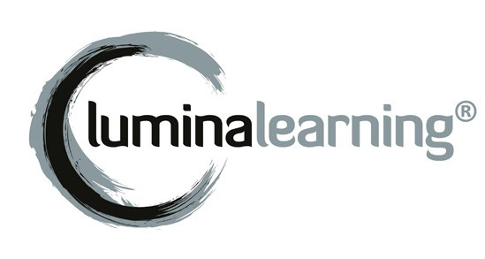
luminalearning.com
©2013 Lumina Learning

06

